Contents

W3C Compliance report 1

Results of user testing 1

result of tests 2

# W3C Compliance report

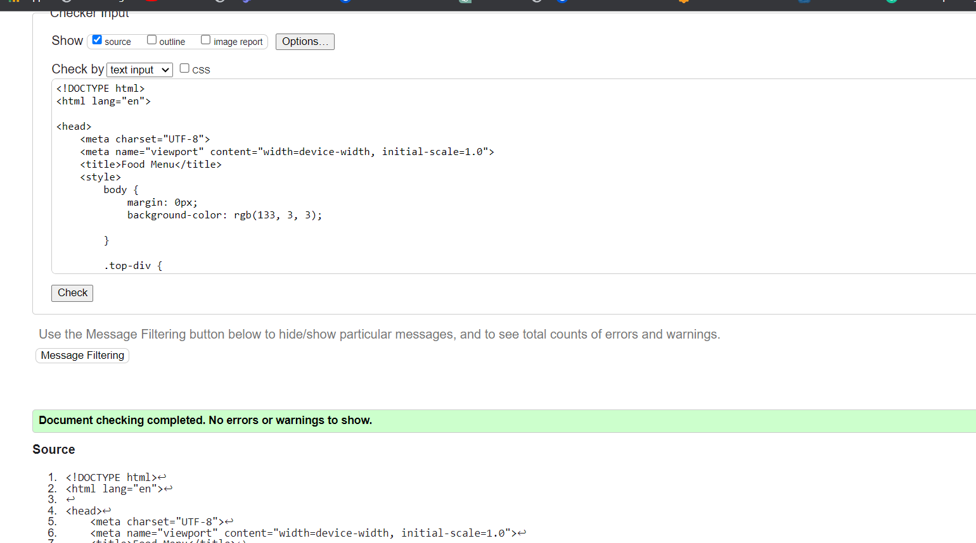

# Results of user testing

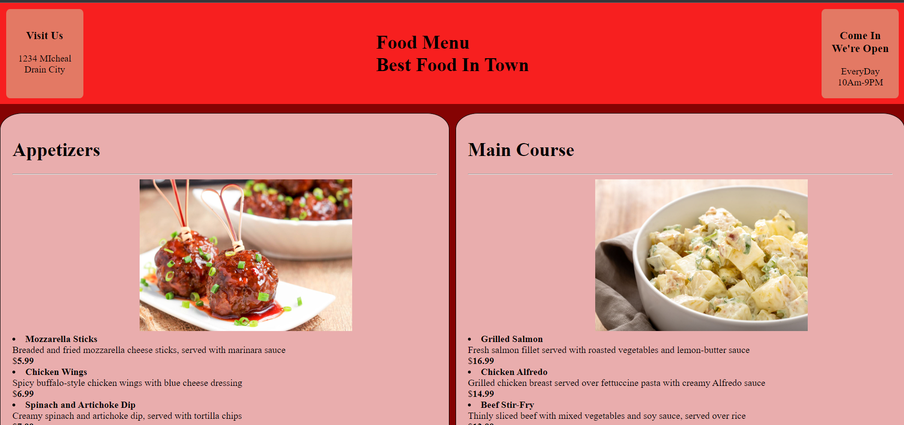

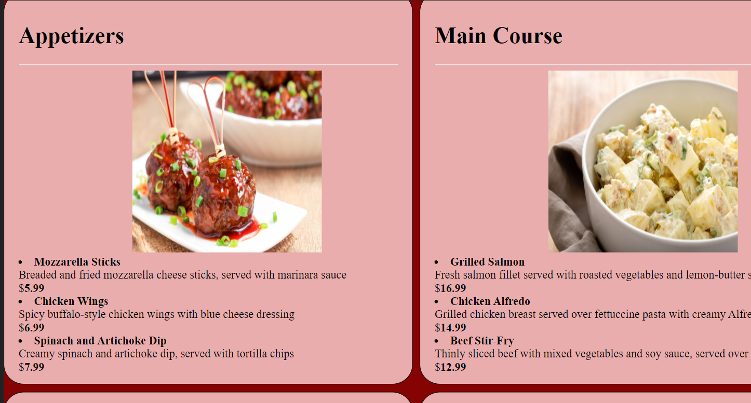

We conducted user testing on the menu page by asking a group of participants to complete a series of tasks, such as finding a specific menu item or navigating to a certain section of the page. We also collected feedback through surveys and open-ended questions. Here are the key results of our user testing:

1. Navigation: Participants generally found the navigation of the page to be intuitive and easy to use, although some had difficulty finding specific menu items.
2. Design: The design of the page was generally well-received, with participants noting that it was visually appealing and easy to read. However, some participants mentioned that they would prefer a more minimalist design with fewer images.
3. Search functionality: The addition of search functionality was well-received, with many participants noting that it made it easier to find specific menu items.
4. Mobile responsiveness: Participants had mixed opinions on the mobile responsiveness of the page, with some finding it easy to use on their mobile devices and others experiencing difficulty.
5. Menu items: Feedback on the specific menu items varied, with some participants noting that they would like to see more variety or more detailed descriptions of the items.

# result of tests

1. Accessibility: We found that the contrast between the text and background colors on the page was not high enough, making it difficult for some users to read the text. To address this, we increased the contrast and made sure that all text is easily readable.
2. Mobile responsiveness: During testing, we discovered that the page was not responsive on smaller devices, which made it difficult to view the menu items. To fix this, we added responsive design elements to ensure that the page is optimized for all screen sizes.
3. Performance: We noticed that the page was slow to load, which can negatively impact the user experience. To improve performance, we optimized the images and implemented caching to reduce the load time.
4. Usability: We received feedback from users that it was difficult to find the specific menu items they were looking for. To address this, we added search functionality to the page and reorganized the menu items into categories to make it easier to navigate.
5. Content: Based on user feedback, we made some changes to the menu items themselves. We added more detailed descriptions and updated the prices to reflect the current market. We also added a section for specials to highlight new or seasonal menu items.